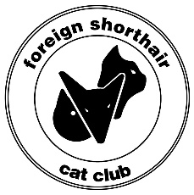
Foreign Shorthair Cat Club of Sth Aust Inc.
Membership Application

NAME:
ADDRESS:

PHONE:
EMAIL:
BREEDS OWNED:
PREFIX:
I/WE wish to apply for membership of the Foreign Shorthair Cat Club of Sth Aust Inc and upon acceptance of MY/OUR application, I/WE agree to abide by the Constitution and Rules of the Club.

Type of membership: _____ Single _____ Family

FOREIGN SHORTHAIR CAT CLUB OF STH AUST INC
AFFILIATED CLUB OF FELINE ASSOCIATION OF SA INC
(FASA IS A MEMBER BODY OF THE CO-ORDINATING CAT COUNCIL OF AUSTRALIA)

*The FSCC holds monthly meetings from February to November inclusive, the Fullarton Park
Community Centre (411 Fullarton Road, Fullarton) in the Howard Room.
*Meetings are held on the 2nd Tuesday of each month at 7.30pm.
*All members are encouraged to attend and visitors are welcome.
*FSCC holds an annual All-breeds Championship Show in July.
Owners of all breeds of cats are welcome to join.

Yearly membership fees: Single $12.00 Family $16.00

Send application to the Treasurer: Payment options:
Debbie Neville Cheque or cash
35 Idlewild Ave, Aberfoyle Park 5159 Direct debit BSB 105-150 A/C 560 319 440
Email: foreignshorthaircatclub@gmail.com

OFFICE USE
DATE RECEIVED:……………………………………………….. DATE NOMINATION ACCEPTED:………………………….

SIGNED:

